PRACTICAL 4B :
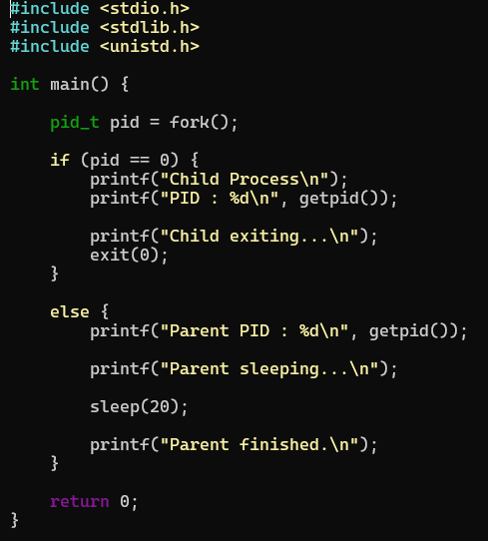
OUTPUT:
